My Travelling Snap
Balazs Barcza
Cloud Platform Programming (PGDCLOUD_SEP 2021)
Postgraduate Diploma in Science in Cloud Computing Information
National College of Ireland
Dublin, Ireland
x19190638@student.ncirl.ie

1. Abstract
The purpose of this assignment is to demonstrate using cloud computing in the example of a web application. This created service contains functional and non-functional requirements. This case study is going to showcase deployment services in the cloud. The paper is to outline the construction and development of the project, evolution, and integration into the cloud. In this project, I'm using version control and many Amazon cloud services.

Keywords: Django, Python, API, AWS Amazon Web Services

2. Introduction
The My Travelling Snaps is a microservice blog chat app. The user can upload photos and discuss their traveling experiences. The feed is live and open to comments and discussion. Topics can be reviewed and stored in the cloud. The front end is simple and easy to navigate. The user can see what is happening in real-time of the post.
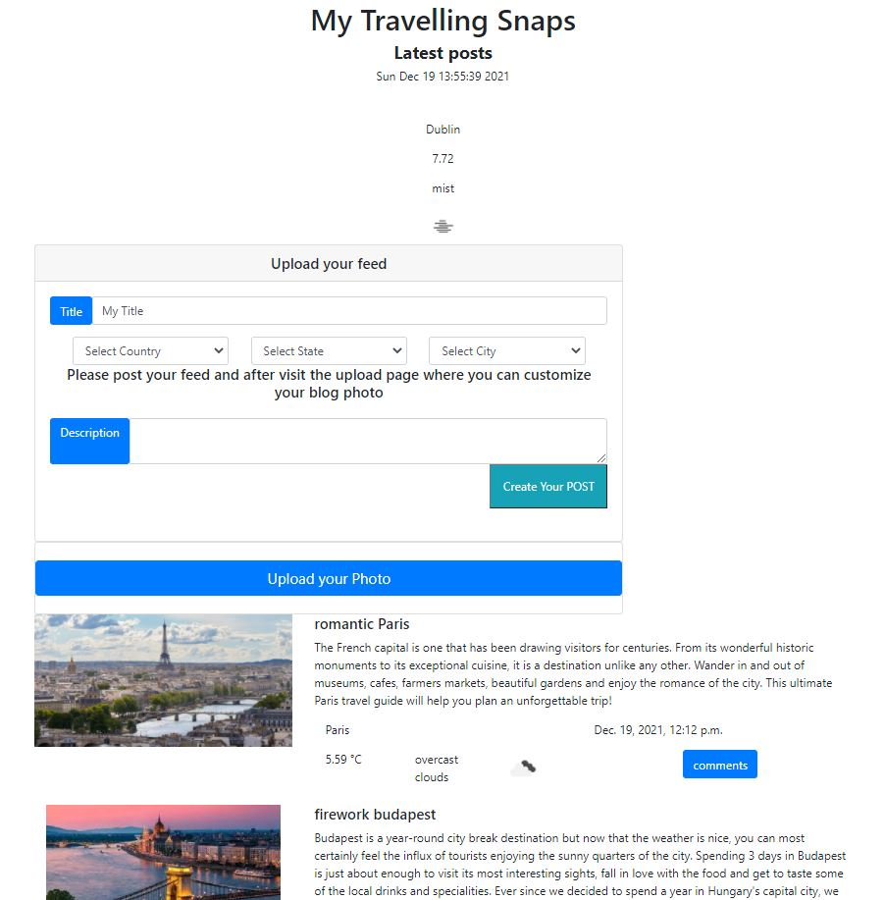

3. Project specification and requirements
In this project, I show knowledge about cloud services. This base application is deployed in the cloud and there have been integrated a couple of Amazon cloud services. The functional requirement of this project is that the blogger/ user gets the real-time water data connected to the location and hosted in the cloud. The non-functional requirement is the user stores data in the cloud database service.”A Functional Requirement (FR) is a description of the service that the software must offer. It describes a software system or its component. ... It can be a calculation, data manipulation, business process, user interaction, or any other specific functionality which defines what function a system is likely to perform.”[1]

4. Architecture and design
This application has to be run on the client device without latency. “Latency is a measure of delay. In a network, latency measures the time it takes for some data to get to its destination across the network. It is usually measured as a round trip delay - the time taken for information to get to its destination and back again.” [2] From an architecture point of view, this is a dynamic web application using different types of tools to achieve a user-friendly experience.
Those tools and frameworks help to create a complete application. The project uses different types of cloud services for example simple storage service and Amazon SNS, CloudWatch providing a complete web service. “Amazon SNS enables you to send notifications directly to your customers. Amazon SNS supports SMS text messaging to over 200 countries, mobile push notifications” [3] This web service helps to develop a much faster and cheaper point. The programmer doesn't have to create their own service or can use it from different types of providers. this is more cost-effective rather than developing all the tools on its own. We can find different types of providers: Google, Amazon, Microsoft ETC. Those providers have similar tools often named differently but most of the services are the same. The programmer can develop their project using one service provider or use a variety of them in the app. The cost may vary but most of the services work on the same principle. In my project, I focused on Amazon's web service point. It's worth mentioning cloud9 AWS Cloud9 is a cloud base integrated development environment (IDE) that lets you write/run/ debug your code with just a browser. it includes a cloud editor, debugger, and terminal. You can use Cloud9's different types of programming languages, including JAVA Script, Python, and PHP. Cloude9 is based in the cloud so you can work anywhere with access to an internet connection. We have to mention EC2. “Amazon Elastic Compute Cloud (Amazon EC2) provides scalable computing capacity in the Amazon Web Services (AWS) Cloud. ... You can use Amazon EC2 to launch as many or as few virtual servers as you need, configure security and networking, and manage storage.” [4] This is a virtual computer in the cloud colled elastic computer cloud offering virtual machine service. We can choose different types of virtual machines: Linux or Windows-based machines and we can decide the hardware equipment. We can carefully design a hosting machine where we can install different dependencies. We can put together a fully functional service in the cloud. Those two tools: Cloude9 and EC2 were the ones I chose to complete my project.
My EC2`s are running.
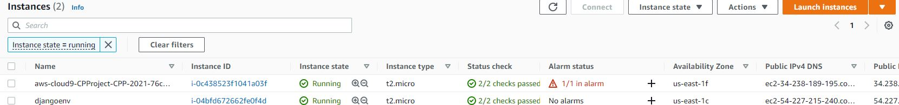
The EC2 machine hosts my final project, Cloude9 helps to develop it. I have to mention GitHub. It's a cloud hosting platform for version control and collaboration. This is also a functional backup. I worked on this project on my own but you can use GitHub to collaborate with different teams. Git Hub essentially holds, branches, commits and pulls requests. My main programming language was Python. I chose it because it's one of the most popular and easy languages to code. It's a perfect programming language for data scientists, machine learning, and scientific artificial intelligence applications. My project is built around Django. Django is a high-level Phyton web framework. Built by experienced developers, it takes care of much of the hassle of web development. Its also free and open source. In the back-end I used Python combined with Django, in the front-end I used Bootstrap. ”Bootstrap is a free and open-source CSS framework directed at responsive, mobile-first front-end web development.” [5] It contains CSS and JavaScript-based design templates for typography, forms, buttons, navigation, and other interface components.
Development happens with creating a basic Django application. Customizing your application you have to import libraries. Those libraries depend on what program you develop. You can find and install Python packages with the Python packaging index. The Python Packaging Index (PyPI) it's a repository o software for Python programming languages PyPI helps you find and install software developed and shared by Python community. I have used time tools 1.0.0. This module provides various time-related functions. pip install times
Other libraries:
python -m pip install requests - Requests is an Apache2 Licensed HTTP library, written in Python, for human beings
pip install boto3 - Boto3 is the Amazon Web Services (AWS) Software Development Kit (SDK) for Python, which allows Python developers to write software that makes use of services like Amazon S3 and Amazon EC2
pip install Pillow - Pillow is the friendly PIL fork by Alex Clark and Contributors. PIL is the Python Imaging Library by Fredrik Lundh and Contributors. As of 2019, Pillow development is supported by Tidelift.
The screenshot shows the pip install successful.

5. Cloud services
Cloud services are infrastructure are infrastructures platforms or software that are hosted by third-party providers and
made available to users through the internet. Users can assess cloud services with nothing more than a computer, operating system and internet connectivity, or virtual private network. There are three main types of cloud computing services: IaaS, PaaS, SaaS. “Infrastructure as a Service (IaaS), Platform as a Service (PaaS) and Software as a Service (SaaS). There are clear differences between the three and what they can offer a business in terms of storage and resource pooling, but they can also interact with each other to form one comprehensive model of cloud computing.”[6]
My main database was provided by Django framework. This database is called SQLLite.
The screenshot was taken from the model.py
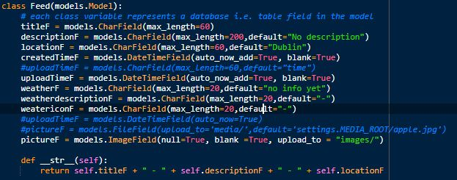
I have created database model and this model include fields: titlef/descriptionF/locationF...
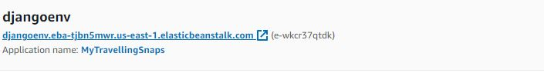
Elastic Beanstalk is the service I used to hose my application in the cloud. AWS Elastic Beanstalk is offered by Amazon web service for deploying applications. The screenshot shows the application was deploy on the Elastic Beanstalk.

You can easily update your instant size, you can connect CloudWatch service.
With AWS CloudWatch I set up a simple alarm system connected to CPU utilization. This way I can monitor my CPU usage.

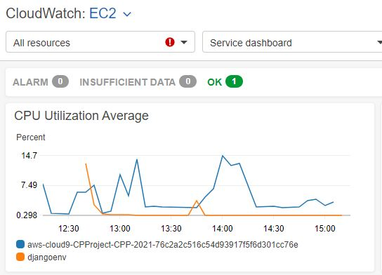
I have implemented rest API from the Open Weather API service. This service provides weather real-time data information. I had to provide the location to the API. In return, I got back a JSON file. This file includes all the details.
urlwithIE = 'https://api.openweathermap.org/data/2.5/weather?q={},{}&units=metric&appid=92757f89a5760a1310e7b5657fff90d2'
city = "Dublin"
r =requests.get(urlwithIE.format(city,"ie")).json()
This code show the openweater API and passing data city = Dublin
This is the REST API provided
{"coord":{"lon":-6.2672,"lat":53.344},"weather":[{"id":701,"main":"Mist","description":"mist","icon":"50d"}],"base":"stations","main":{"temp":6.94,"feels_like":6.36,"temp_min":6.36,"temp_max":7.71,"pressure":1032,"humidity":94},"visibility":2200,"wind":{"speed":1.34,"deg":51,"gust":2.68},"clouds":{"all":75},"dt":1639927557,"sys":{"type":2,"id":2016139,"country":"IE","sunrise":1639903033,"sunset":1639930035},"timezone":0,"id":2964574,"name":"Dublin","cod":200}
My traveling app saves the pictures in the cloud and uses the AWS S3 bucket. Using the service you are able to upload a picture on S3. I have created a bucket holding all the images. The blog title, weather, and description are held in SQLite.
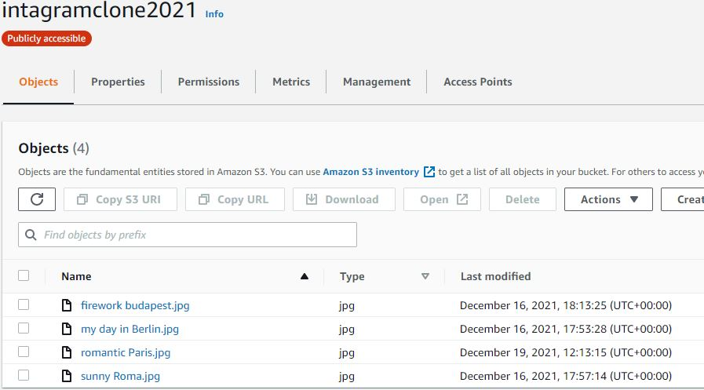
I used the Amazon Lambda service to create a real-time notification. The user uploads a picture to the S3 bucket the Amazon Lambda will be triggered, the code will respond to an event and automatically manage the Amason SNS notification.
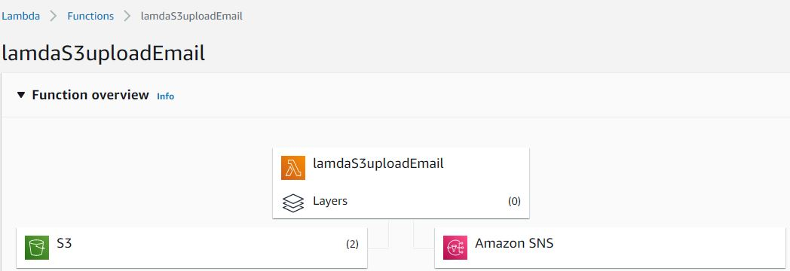
I have posted a picture on the website. This is the e-mail that the SNS server sent to me.
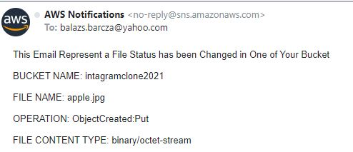
Amazon Lambda is connected to the bucket. When uploading any picture to the storage, Lambda automatically triggers Amazon SNS. Every time a user posts a new picture the SNS generates an email notification about the new post.
“AWS Lambda is a serverless, event-driven compute service that lets you run code for virtually any type of application or backend service”[7]

6. Implementation
My application framework is based on Django so before I have uploaded my app to Elastic Beanstalk I had to make a couple of set up. I have created a requirements.txt file. This file includes all of the dependence. All of the packages are installed in your virtual environment.
pip freeze > requirements.txt
I have configured my Django application for Elastic Beanstalk. /myapp/.ebextensions/django.config
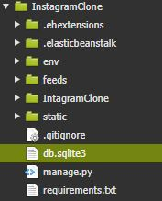
I have created an environment and deployed my application to it with eb create.

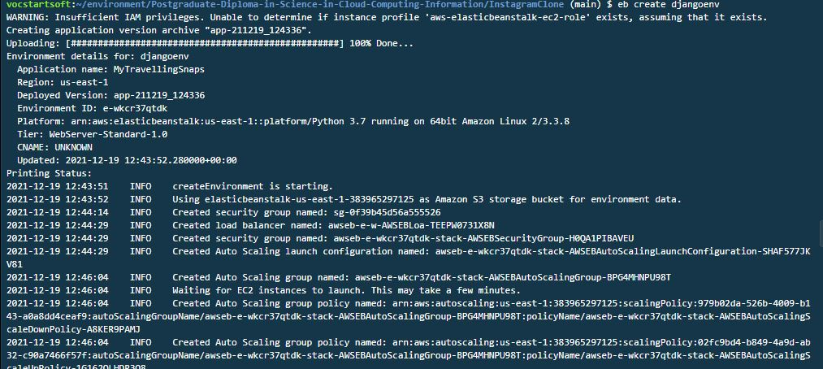
The URL to my web application:
http://djangoenv.eba-tjbn5mwr.us-east-1.elasticbeanstalk.com/

I have used GitHub distributed version control. I have uploaded my source code there, anytime I can manage my functionality. My code repository URL:
https://github.com/Balays33/Postgraduate-Diploma-in-Science-in-Cloud-Computing-Information

The video presentation to my project:
https://youtu.be/PsCMtXw2AHg

7. Future opportunities:
In the future, I would like to develop a real-time chat section, where you can discuss the recent post. Potentially using DynoamoDB service as well to be able to trace down and filter historical conversations. Another development opportunity is the ability to create a profile page with the ability to follow other users.

8. Post on the Application
step 1 – create blog
the location from API
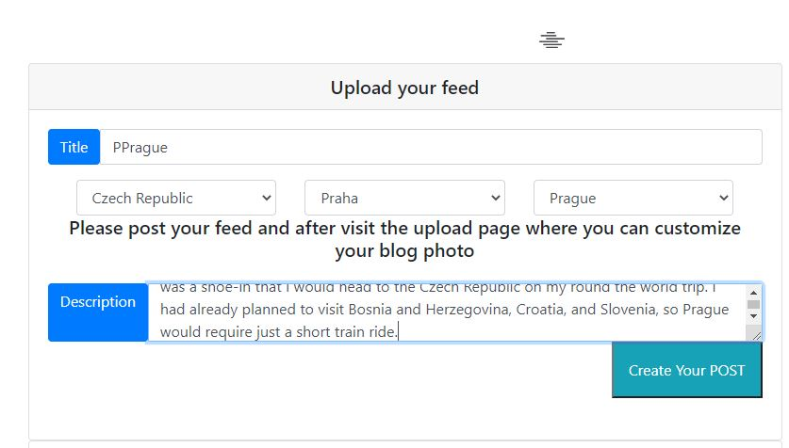
step 2 – post is suspenseful
just has to add the picture to the AWS S3
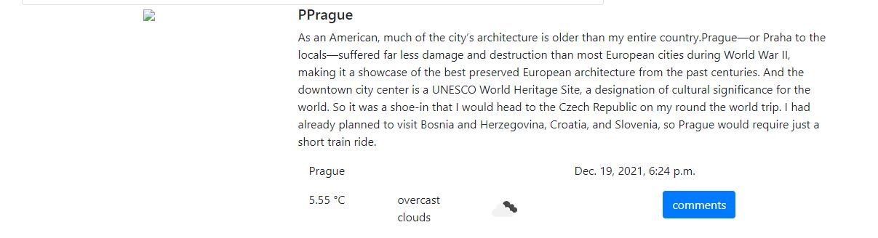
step 3 – visit the upload page (separate page unfortunately I could not make a same time the upload the blog and picture some bug in the program)
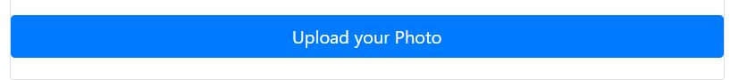
step 4 – the photo name = the blog title = primary key
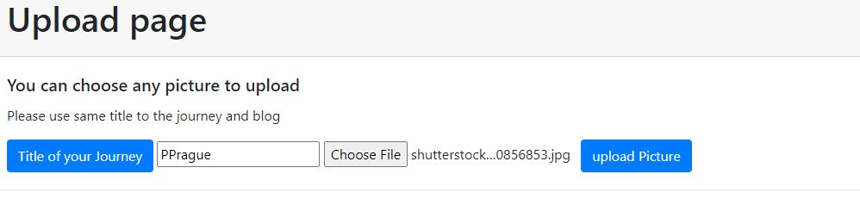
step 5 – upload the picture is susessful
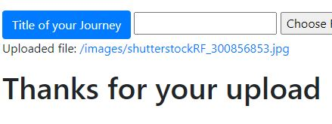
step 6 -visit the main page the blog post include the picture + the live temperature information API


9.References
1. Matthew MartinUpdatedOctober 6, 2021 : What is a Functional Requirement in Software Engineering? Specification, Types, Examples https://www.guru99.com/functional-requirement-specification-example.html
2. https://www.sas.co.uk/blog/what-is-network-latency-how-do-you-use-a-latency-calculator-to-calculate-throughput
3. https://aws.amazon.com/sns/?whats-new-cards.sort-by=item.additionalFields.postDateTime&whats-new-cards.sort-order=desc
4. https://docs.aws.amazon.com/AWSEC2/latest/UserGuide/concepts.html
5. Otto, Mark (January 17, 2012). "Bootstrap in A List Apart No. 342". Mark Otto's blog. Archived from the original on October 28, 2016. Retrieved February 23, 2017.
6. https://www.leadingedgetech.co.uk/it-services/it-consultancy-services/cloud-computing/what-are-the-types-of-cloud-computing/
7. https://aws.amazon.com/lambda/

